**Fabric and window treatments**

**IDEC1045**

**Valances and fabric shades**

1. Replace the highlighted areas above.
2. Fill in the cells on the right in the table below.

## Week at a Glance

|  |  |
| --- | --- |
| **Week at a Glance** | |
| This week’s course learning outcomes (number and text) | **CLO04:** Outline current fabric trends including pattern, texture and styles as well as uses and benefits of linings to create quality window treatments for various uses.  **CLO05**: Calculate both hard and soft treatments to custom order from a manufacturer or seamstress based on appropriate measurements to complete window treatment order for a client. |
| This week’s unit learning outcomes (number and text) | **Text:** Designing Interiors 2nd, pages 478-480, 482  **Unit 3:**  3.4 Recognize the importance of lining to success of drapery appearance and durability  **Unit 4:**  4.4 Compare differences in ready-made and custom treatment quality and cost differences  **Unit 5:**  5.2 Explain the fabrication and uses of a Velcro board  **Unit 6:**  6.2 Calculate fabric requirements for common valances and soft fabric shades |
|  | |
| This week’s problem | To date the student has learned to calculate soft and hard window treatments. This week is the final subject dealing with valances and soft shades that will give them the knowledge to plan and calculate all areas of window treatments that are used in today’s decor |
| How does this week’s problem fit into the course so far? | This is the final stage of calculating window treatment categories. |
| List of topics and subtopics that will be covered to address this week’s problem | **Soft Valances**: how they are used, styles popular, sizing and measuring, correct linings and hanging options, returns  **Soft Shades**: description and how they are used, styles popular, sizing and measuring, correct linings and hanging options.  **Layering:** How valances and shades can be used in conjunction with both hard and soft treatments. |
| If this is a hybrid course, what topics and activities will be covered in-class to support the online content? |  |
| How does problem fit into the remaining weeks of the course? | This week is the remaining category the student needs to know about regarding window treatments. The student will use this week’s lesson to complete assignments, mid-term and exam and final project. |
|  | |
| Graded Assessment? | Yes. Fill out the Evaluation section below.  No. |

## Introduction

|  |  |
| --- | --- |
| **Introduction to Week** | |
| Introduction | Description of content for this week:   * Explain what the user will learn * Describe the problem the user will be able to solve by the end of week * Answer the question “What’s in it for me (the learner)?”   In previous weeks you have learned about drapery and hard window treatments. This week is the final category of window treatments focusing on soft valances and shades that can be used on their own or layered with soft and hard window coverings. While you may have some preferences as to the kind of window treatments you prefer, styles do come and go and it is important to be knowledgeable of all categories so that you are prepared for client requests and what treatment is best for any window. Therefore this week we will look at soft valances and shades and how to calculate for the more common styles on today’s market. You will have an assignment due at the end of this week on this topic so make sure to give yourself enough time to complete it before next week. |
| Learning Outcomes | Write out the week’s unit learning outcomes here (number and text).  **Text:** Designing Interiors 2nd, pages 478-480, 482  **Unit 3:**  3.4 Recognize the importance of lining to success of drapery appearance and durability  **Unit 4:**  4.4 Compare differences in ready-made and custom treatment quality and cost differences  **Unit 5:**  5.2 Explain the fabrication and uses of a Velcro board  **Unit 6:**  6.2 Calculate fabric requirements for common valances and soft fabric shades |
| Other relevant announcements/ reminders | Insert notes on assignments and/or anything out of the ordinary.  Note: You can also add an image here for a front cover page look and feel.  There is an assignment on valances and shades due by the end of this week’s lesson.  Istock id: 529558821  C:\Users\Linda\Downloads\529558821.jpg |

****************** Beginning of instructional content ************************

# Valances and shades:

Valances and shades are soft treatments made with fabric. The valance is stationary and decorative only covering the top area of the window, while a soft shade is able to move up and down to open and close over a window. Both can be inside or outside mount and need linings. All valances and shades need 2” past the window trim minimum for outside mounts. Certain styles require returns (area from the front of the treatment to the wall).

This is the same drawing shown in week 6 to use here, redrawn to cover copyright

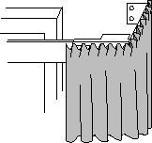The return is the treatment from the front back (returning) to the wall bracket.

Returns are usually between 3” – 5” on an outside treatment. If you are using a valance with a blind, or drapery treatment underneath it, you need to make sure the return is deep enough to allow the treatment underneath to operate without rubbing on the valance.

The window measurements are taken the same as all other windows and recorded along with a ½” scale drawing on graph paper as a working copy.

Valances and shades can be used alone on a window or layered with any other style of hard or soft treatment. Since they are made from fabrics, there are thousands of choices and price ranges to choose from so the options can be endless to give a unique touch as a window treatment.

Soft Valances:

Soft valances are a top treatment as a decorative element to a window that are hung at the top of the window between the trim and the ceiling heights depending on the look desired. They are short only covering a few inches of the top of the window below the trim. A valance can offer a lesser amount of fabric that adds texture, colour or pattern to a window. They can also be useful to cover a non-decorative rod like an I beam.

There are many styles of valances and we will look at some of the most popular ones used today, how to calculate the style and what kind of lining and hanging are required.

When creating valances, proportion is very important. Do not make them too short. The average finished length of a valance is between 15” – 24” in size. Usually it is not recommended to cover more than 20% of the window length to allow as much light as possible into the room and this is why valances are often hung high on the wall towards the ceiling. If you are using a valance on an outside door or French door the length can be less at about 10-12” to be in proportion to the door size.

### Pleated:

Pleat style valances are usually hung on decorative rods or an I beam and calculated exactly the same as side panels, however they cover across the whole top of the window and are much shorter. Outside mount valances have a return to the wall. We mentioned returns in an earlier week and I will show you how to calculate these here. The return gives a finished look to an outside mount valance.

**Example to Calculate:**

* Pinch pleated valance, outside mount with 4” returns
* Window 60” wide X 48” long with 6” trim added to the window size
* 8’ ceiling
* Hang 6” above the top window trim on an I beam
* Length to cover 3” of the window glass
* Plain fabric with no repeat
* Lining needed?

**Answer:**

* Draw ½” scale drawing on graph paper as your working copy

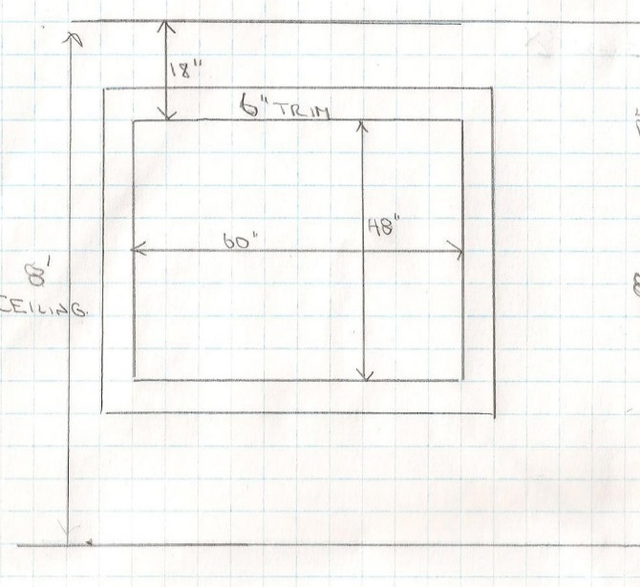

**Width:**

* Outside mount means the valance has to come past the side width by 2” on each side.
* Window width = 4” return + 2” past + 6” trim + 60” window + 6” trim + 2” past + 4” return = 84” of space needed.
* Finished width needed does not include returns because they go back from the front of the treatment. Finished width = 2 past + 6” trim + 60 window + 6” trim + 2 past =  **finished width of treatment = 76” with 4” returns** (84” – 4 - 4 returns = 76”)
* Pleated header treatment is 2 ½ fullness to pleat the treatment to cover this area
* 84” X 2.5 fullness = 210” +6” salvage edge finishing (as valance is sewn together as 1 panel) = 216” fabric width.
* Since fabric is 54” wide, you need to see how many cuts of 54” fabric you need to allow for 216” of width.
* 216” divided by 54 = **4 cuts**. You need 4 pieces (no need to round up as the amount = full cut) of 54” fabric to sew together to make the width needed for this treatment

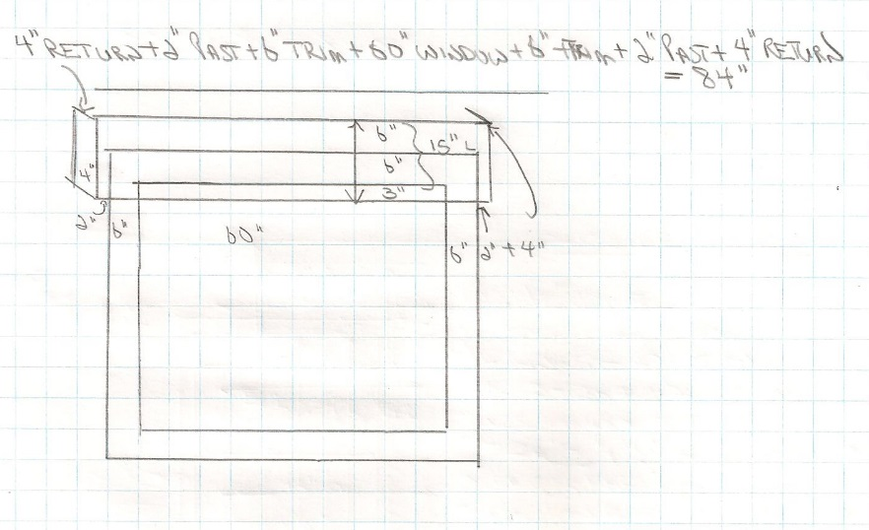

**Length:**

* Hung 6” above the trim: 18” from glass to ceiling – 6” trim = 12” of wall space.
* Hang 6” above trim = 12” wall space – 6” above to hang = 6” left to ceiling. Therefore hang 6” below ceiling.
* Length to cover 3” of glass from 6” above the top trim
* Add 6” above trim + 6” trim + 3” past = **15” finished length**
* This is not the amount to order. Pleated style needs 16” to make hem and header
* 15” + 16” = 31” of fabric length X 4 cuts = 124” on fabric to order = divide by 36” = 3.4 yards of fabric. Round up to **3 ½ or 3 ¾ yards to order.**
* Since there is no pattern, order the same amount of lining.

### Box:

Box pleat valances are among the most timeless styles that can suit every style. The treatment appears flat across the front yet has pleats in varying sizes across the face of the window. It can have bands of contrasting fabric for a decorative effect or can be scalloped or arched for a softer look and can even have the pleats in a different fabric. The wider the box pleat, the more modern it will look and the more pleats closer together appear more traditional.

Istock id: 528955284

When calculating the length for a shaped box pleat style use the longest length of the treatment to measure for yardage.

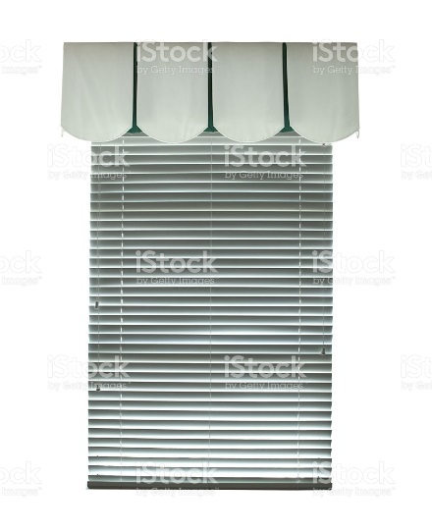

By Linda Guthro

This is a box pleat with a pleat in the middle and ½ pleat on each corner. There is a slight curve to the bottom of the treatment

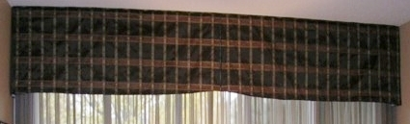

For each full pleat you will need to add 18” of width to your calculations and for each corner you will need to add 9” for a ½ pleat.

Outside mounts still need to run 2” past the window frame on each side and returns usually between 3” – 5”.

**NOTE:** For smaller multiple pleats instead of calculating each pleat you can take the total width X3 + 6” salvage for the width. Still add window returns+ trim + past on sides by 2” minimum x 3 +6” salvage = width. Divide by 54 to get # of cuts.

**Interesting note:** Another consideration for this kind of treatment is that if you are putting it on a large window with divisions you would want to have the pleats match up with the window trim.

By Linda Guthro

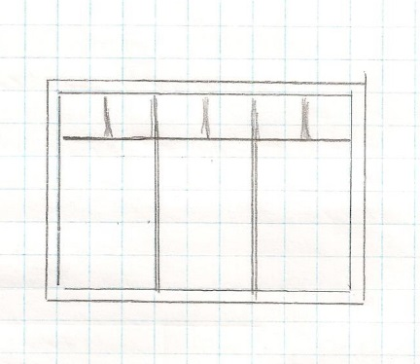

**Calculate:**

* Box pleat valance, outside mount with 4” returns
* 1 full pleat in middle and ½ pleat on each corner
* Window 60” wide X 48” long with 6” trim added to the window size
* 8’ ceiling
* Hang at ceiling height on a Velcro board
* Length to cover 3” of the window glass
* Plain fabric
* Lining needed?



**Answer:**

**Width:**

* Outside mount means the valance has to come past the side width by 2” on each side.
* Window width = 4” return + 2” past + 6” trim + 60” window + 6” trim + 2” past + 4” return = 84” of space needed.
* Finished width needed does not include returns because they go back from the front of the treatment. Finished width = 2 past + 6” trim + 60 window + 6” trim + 2 past =  **finished width of treatment = 76”**  (84” – 4 - 4 returns = 76”)
* Box pleat header treatment needs 1 full pleat of 18” and a ½ pleat at each corner of the treatment to cover this area
* 4” return + 2” past + 6” trim + 60” window + 6” trim + 2” past + 4” return = 84” of space needed. + 18” full pleat in middle + 9” +9” (1/2 pleats at each corner) = 84 + 18 + 9 + 9 = 120” + 6” salvage = (as valance is sewn together as 1 panel) width of fabric to make this treatment **= 126” in total**.
* Since fabric is 54” wide, you need to see how many cuts of 54” fabric you need to allow for 126” of width?
* 126” divided by 54 = 2.3 cuts. Round up to the next full cut size = **3 cuts** of 54” fabric to sew together to make the width needed for this treatment.

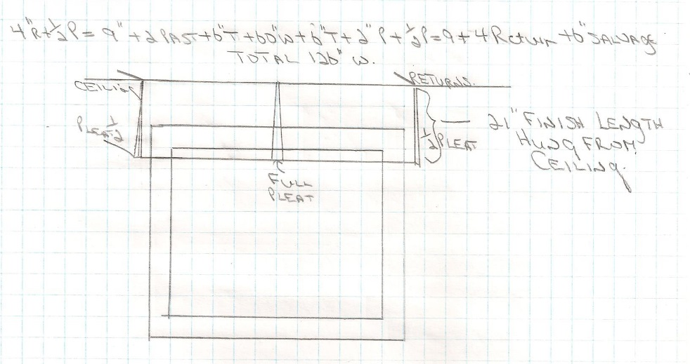

**Length:**

* Hung at ceiling height and cover 3” of glass = 18” from ceiling to glass(12” wall + 6” trim) + 3” over glass = **21” finished length**
* This is not the amount to order. Box pleat style needs 12” to make hem and header
* 21” finished length+ 12” hem and header = 33” of fabric length X 3 cuts = 99” of fabric to order = divide by 36” = 2.75 yards of fabric. Round up to **3 yards to order.**
* Since there is no pattern, order the same amount of lining.
* This kind of treatment can look fuller and more finished with an interlining as well. Any treatment that has a large flat surface it is recommended to add an interlining. An interlining for this treatment would also be the same amount as the regular lining and the fabric amount of 3 yards.

This website shows many looks for box pleat valances

<http://www.houzz.com/box-pleated-valance>

### Mock Roman:

A mock roman valance is meant to look like an operating roman shade but is stationary. It has folds sewn to look like a waterfall as a roman shade would look if it was raised up on the window. This is an attractive and tailored style that suits most styles of décor. As with the box pleat the hem and header are 12” in length needed. Outside mounts will have a return as well

By Linda Guthro

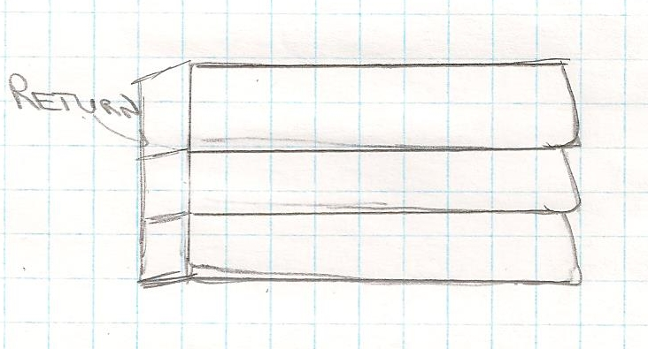

**Calculate:**

* Calculate a Mock Roman valance, inside mount
* Window 60” wide X 48” long with 6” trim added to the window size
* 8’ ceiling
* Hang inside the trim on a Velcro board
* Pattern repeat of 10”
* 3 folds in the valance
* Valance finished length 18”
* Lining needed

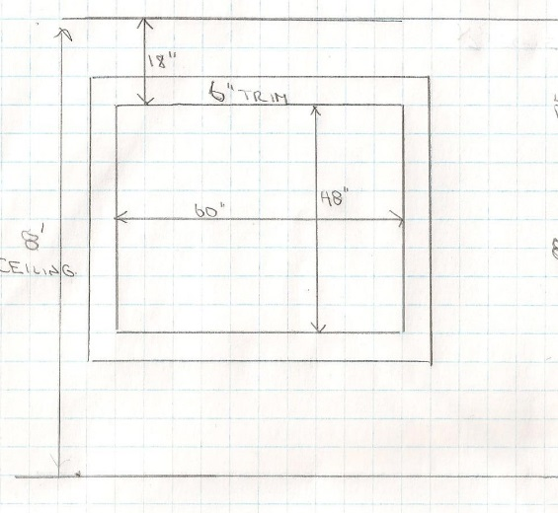

**Answer:**

**Width:**

* Inside mount means that the treatment sits inside the trim measure
* Window width = 60” window inside mount
* Finished width needed will be the size of the window as seamstress will automatically deduct 1/8” on each side to allow for movement in the window. Make sure to order by the narrowest width of the window measure.
* **Finished width = 60”**
* 60” window + 6” salvage = (as valance is sewn together as 1 panel) width of fabric to make this treatment **= 66” in total** needed to order.
* Since fabric is 54” wide, you need to see how many cuts of 54” fabric you need to allow for 66” of width?
* 66” divided by 54 = 1.2 cuts. Round up to the next full cut size = **2 cuts** of 54” fabric to sew together to make the width needed for this treatment.
* What will happen for this treatment is that the 54” piece will be used in the middle and the extra width will be added to each side to keep the seams unobtrusive on the treatment.

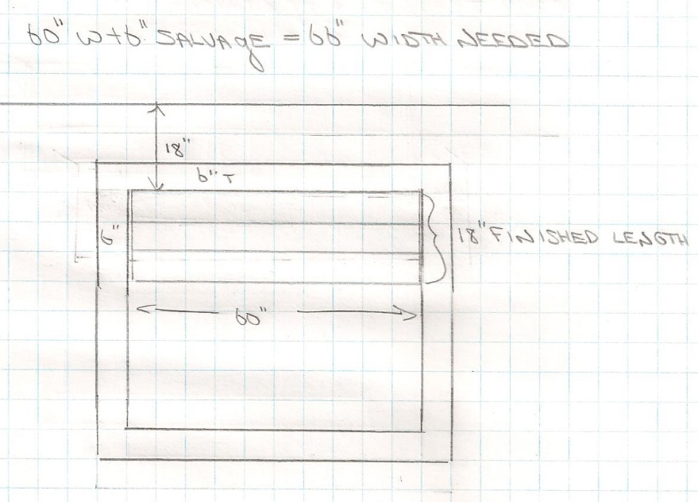

**Length:**

* Hung inside mount inside the trim
* **Finished treatment to be 18” in length**
* This is not the amount to order.
* Mock roman style needs 12” to make hem and header
* 18” finished length+ 12” hem and header = 30”
* Have a pattern repeat of 10” that needs to be added to the length: 30” + 10” pattern repeat = 40”
* To make a mock roman the fabric needs to be folded 16” for each fold of fabric length
* 40” + 16 fold+ 16 fold + 16 fold = 88” length to order
* We need 2 cuts of fabric to make this treatment so 88” length X 2 cuts = 176”of fabric to order = divide by 36” = 4.8 yards of fabric. Round up to **5 or 5 ¼ yards to order.**
* **Lining**: Do not include pattern repeat for any lining. Since there is a 10” pattern repeat, order 88” – 10” repeat = 78 x 2 cuts = 156” divided by 36 = 4.3 yards of lining and interlining each. Round up to 4 ½ yards.
* An interlining is a recommended option to give more body to the folds and give a more custom look to the treatment. Interlining would be 4 ½ yards.

### Swag and Jabot:

A swag and Jabot treatment is a traditional and rather formal look. It has swags across the window from single to multiple depending on the window size. The fabric runs railroaded so that there are no seams on each swag. Swags are measured railroaded so that the width becomes the length of the swag. A 54” fabric swaged is about 18” at the longest part of the swag. Each swag needs 1 ½ yard per swag. A Jabot is the amount that hangs down on each side of the window and usually is at least 1/3 -2/3 of the window length.

**For one swag** calculate the width of the window + 30% for the swag and divide by 36 for yardage.

**For multiple swags,** each swag measures 18” width and takes 1 ½ yards per swag. Swags can also overlap across a window for a richer look.

**The jabot** is the decorative piece constructed to create a cascading effect that will cover the trim and be placed under a swag. Measure the length of the jabot you want to hang from the Velcro board and add 10” to finish the ends + a pattern repeat if there is one. You would multiply this by 2 for a pair of jabots.

Istock id: 481183920

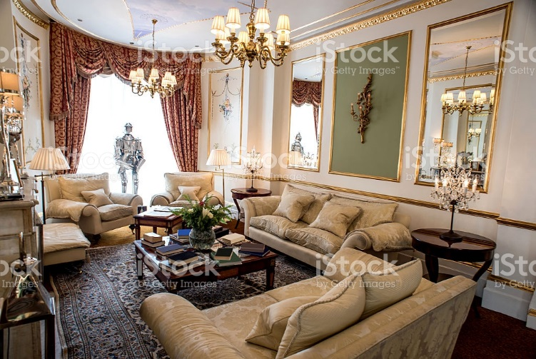

* Swag and Jabot valance, outside mount with 3” returns
* 3 swags across the window and 2 Jabots ½ way down the window length.
* Window 60” wide X 48” long with 6” trim added to the window size
* 8’ ceiling
* Hang 4” above the top trim on a Velcro board
* Plain fabric
* Lining needed



**Answer:**

**Width:**

* Outside mount means the valance has to come past the side width by 2” on each side.
* Window width = 3” return + 2” past + 6” trim + 18 +18 +18”swags + 6” trim + 2” past + 3” return = 76” of space needed.
* Finished width needed does not include returns because they go back from the front of the treatment. Finished width = 2 past + 6” trim + 18” + 18” + 18” swags + 6” trim + 2 past =  **finished width of treatment = 70”**
* Since the swag is railroaded the 54” width becomes the length of the swag and so no more calculations are needed for the width. We know each swag takes up 18” in width

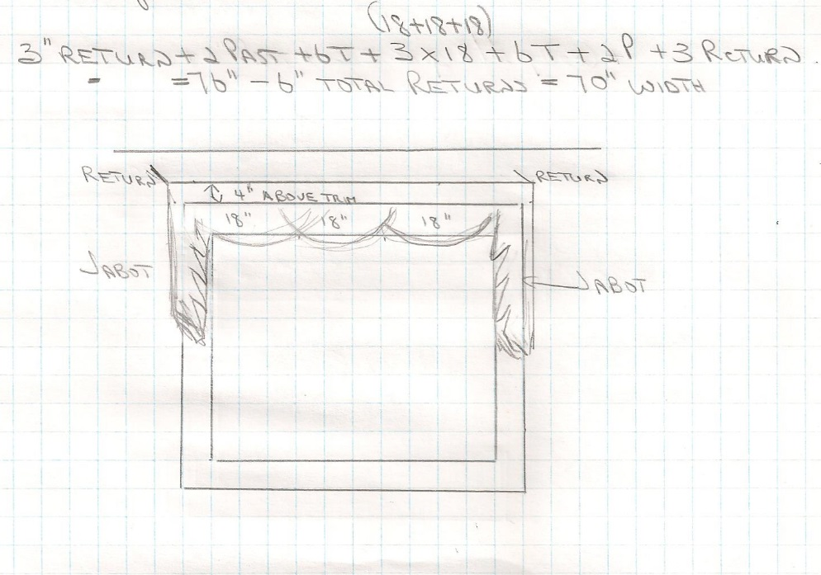

**Length:**

* Hung 4” above the trim: 18” from glass to ceiling – 6” trim = 12” of wall space.
* Hang 4” above trim = 12” wall space – 4” above to hang = 8”” left to ceiling. Therefore hang 8” below ceiling.
* Swag is railroaded so that each 18” swag needs 1 ½ yards
* Multiply 1 ½ yards X 3 swags = **4.5 yards for swags**
* Jabots are finished 1/2 way down the window = 4” above trim + 6” trim + 24” for ½ length of window = **34” finished length** + 10” hem and header = 44” needed for each jabot X 2 jabots = 88” divided by 36” in a yard = 2.44 yards.
* Add swag yardage of 4.5 + jabot yards = 2.44 = 6.94 yards total. Round up to **7 yards to order**
* Since there is no pattern, order the same amount of lining. Linings can be discrete for this style often because it shows in the folds of the jabots. That showing lining would be the same yardage as the Jabot and you can use regular lining for the swag.

Soft Shades:

Soft shades are made from a material like you would use on drapery treatments. They can be inside or outside mount and operate with rings sewn to the back of the treatment and uses cords to operate the motion. They can be used on their own or in conjunction with a valance, side panels or functional drapery. Any flat shade should have a lining and interlining to give enough body and structure to the treatment, so always plan for both linings when calculating. A blackout lining is also an option when wanting almost total darkness when closed. Some soft shades can be gathered on a pocket rod, however the majority and styles are hung from a Velcro board for both inside and outside mount.

**Flat Roman:**

A flat roman shade is probably the most common kind of shade in today’s décor. It is flat when closed and folds up in pleats when raised. This style of treatment fits all types of décor and is a clean, tailored look that can really show off a fabric pattern or texture as it is flat on the window when closed. **NOTE:** You cannot have a return on an operating roman shade as it will bunch up when operating. To have the Velcro board blend into the treatment more, upholster the Velcro board to match the shade fabric.

Measurements are taken the same as on all windows and a ½” scale working copy should always be drawn to plan your treatment.

For an inside mount always check that there is enough depth to allow the treatment to operate inside the window trim. Always state what side you want the operating cord to be placed as done with hard blinds (left or right side).

Outside mounts still go past the window 2” minimum and can hang from 4” above the trim to right up to the ceiling. Always add 6” to the width to finish the salvage edge.

**Roller blind:** is a blind that is flat like the roman but rolls up and down instead of folding. The calculations are exactly the same as the flat roman style.

Istock id: 147658450

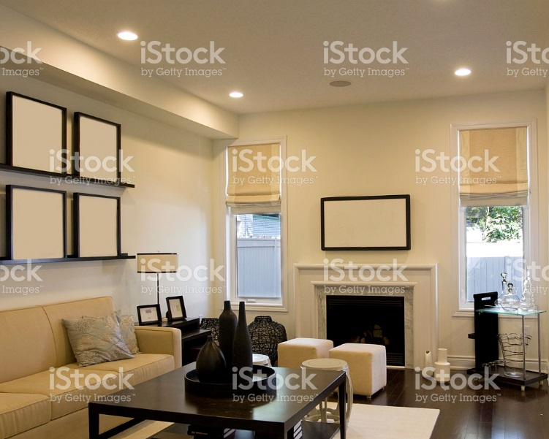

**Calculate:**

* Calculate a Flat roman shade inside mount
* Window 60” wide X 48” long with 6” trim added to the window size
* 8’ ceiling
* Hang inside the trim on a Velcro board
* Pattern repeat of 15”
* Lining and interlining needed?



**Answer:**

**Width:**

* Inside mount means that the treatment sits inside the trim measure
* Window width = 60” window inside mount on a Velcro board
* Finished width needed will be the size of the window as seamstress will automatically deduct 1/8” on each side to allow for movement in the window. Make sure to order by the narrowest width of the window measure.
* **Finished width = 60”**
* 60” window + 6” salvage = (as valance is sewn together as 1 panel) width of fabric to make this treatment **= 66” in total** needed to order.
* Since fabric is 54” wide, you need to see how many cuts of 54” fabric you need to allow for 66” of width?
* 66” divided by 54 = 1.2 cuts. Round up to the next full cut size = **2 cuts** of 54” fabric to sew together to make the width needed for this treatment.
* What will happen for this treatment is that the 54” piece will be used in the middle and the extra width will be added to each side to keep the seams unobtrusive on the treatment.

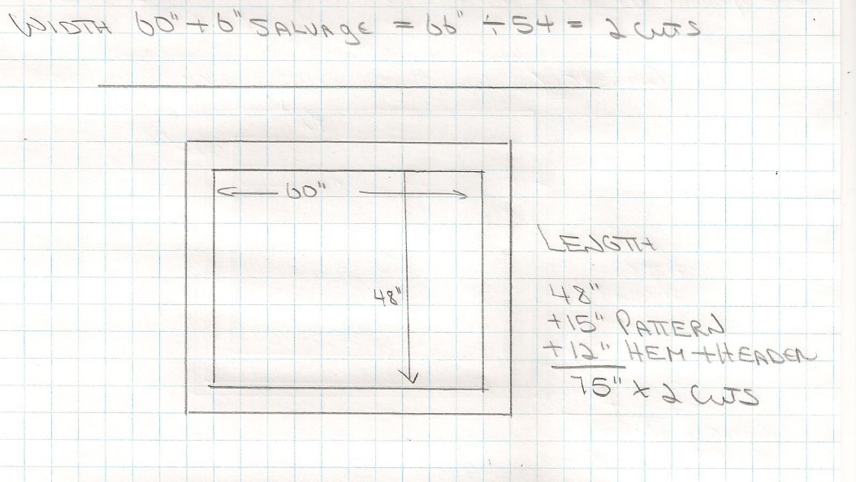

**Length:**

* Since inside mount measure the length of the window and use the longest measure.
* Length = 48” long
* This is not the amount to order.

Flat roman shade style needs 12” to make hem and header

* 48” finished length+ 12” hem and header = 60”
* Have a pattern repeat of 15” that needs to be added to the length: 60” + 15” pattern repeat = 75”
* We need 2 cuts of fabric to make this treatment so 75” length X 2 cuts = 150”of fabric to order = divide by 36” = 4.16 yards of fabric. Round up to **4½ to 4 ¾ yards to order.**
* **Lining**: Do not include pattern repeat for any lining. Since there is a 15” pattern repeat, order 75” – 15” repeat = 60 x 2 cuts = 120” divided by 36 = 3.3 yards of lining and interlining each. Round up to 3 ½ yards.
* An interlining is a recommended option to give more body to the folds and give a more custom look to the treatment. Interlining would be 3 ½ yards.

**Hobbled Roman:**

A hobbled roman shade is one that has folds still showing even when closed. This takes much more fabric to make. It can be inside or outside mounted with no returns and hung on a Velcro board. Width would be measured to include past the window trim, trim, window area and salvage. To calculate the length you would measure the finished length (how high above the trim, window and trim length and 2” below trim. Use this total measure X 2.5 for the amount to order. This 2.5 amount added to the finished length will also include the hem and header. Inside mount would be the narrowest width on the window + the longest length of the window X 2.5 for the order length.

**NOTE:** Due to the amount of fabric needed for this treatment a wide window should have multiple shades across the width so that the treatment remains easy to operate up and down.

This website is a good example of hobbled shades

<http://www.houzz.com/hobbled-roman-shade>

Can we redraw this to cover copyright?

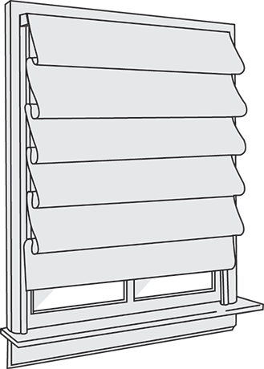

**Calculate:**

* Calculate a Hobbled roman shade outside mount
* Window 60” wide X 48” long with 6” trim added to the window size
* Hang 6” above the top trim on a Velcro board
* 8’ ceiling
* Plain fabric
* Lining and interlining needed?



**Answer:**

**Width:**

* Outside mount means that the treatment will extend 2” past the trim
* Window width = 60” window outside mount on a Velcro board
* 2” past trim + 6” trim + 60” window + 6” trim + 2” past = 76” + 6” salvage = 82” total width needed.
* Do not include salvage in finished width: 82” – 6” = **76” finished width**
* Since fabric is 54” wide, you need to see how many cuts of 54” fabric you need to allow for 82” of width?
* 82” divided by 54 = 1.5 cuts. Round up to the next full cut size = **2 cuts** of 54” fabric to sew together to make the width needed for this treatment.

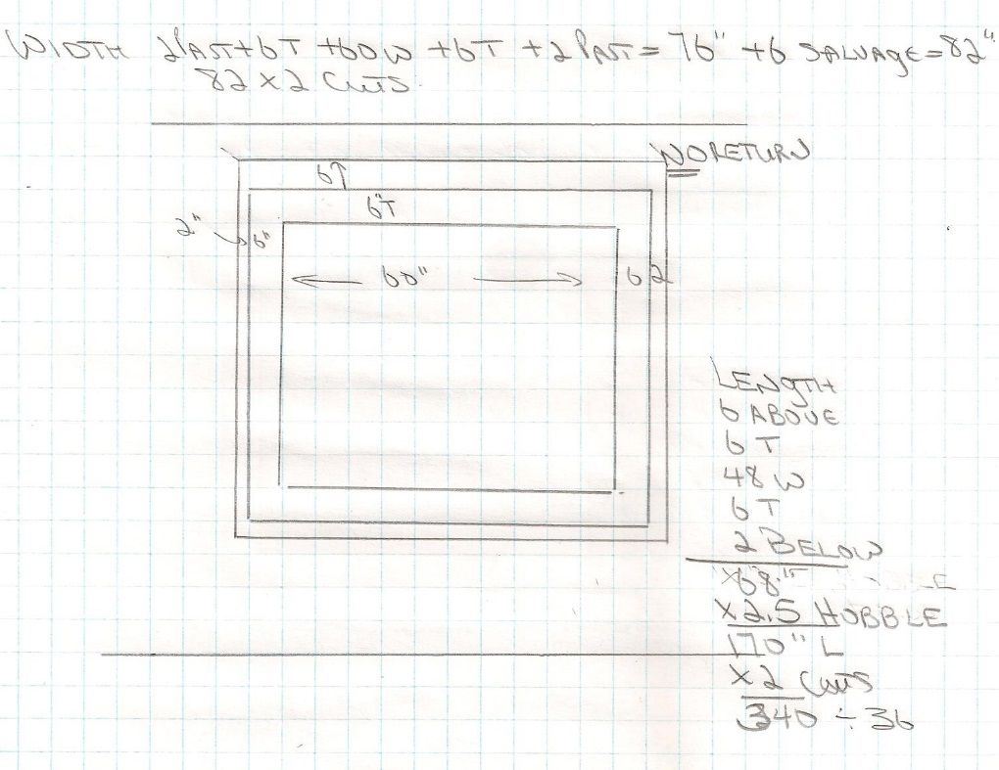

**Length:**

* Since outside mount measure 6” above trim + 6” trim+ length of window 48”+ bottom trim 6” + 2” below trim = **68” finished length.**
* This is not the amount to order.

Hobbled roman shade style needs 2.5 times this length to make (included hem and header)

* 68” finished length multiple by 2.5= 170” in length to order
* We need 2 cuts of fabric to make this treatment so 170” length X 2 cuts = 340”of fabric to order = divide by 36” = 9.44 yards of fabric. Round up to **9½ to 9 ¾ yards to order.**
* **Lining**: Same amount of lining and interlining needed to order.
* An interlining is a recommended option to give more body to the folds and give a more custom look to the treatment.

**Balloon:**

A balloon shade is a traditional treatment that had inverted pleats for a softer look that billows at the bottom and is hung on a Velcro board. This treatment has a full look that requires 3 times to total width to create. There is also 20” added to the finished length for a hem and header and a relaxed bottom. You can have different number width of billows depending on the size of the window. You will see it takes a lot more fabric to make than most shades. Because this treatment is so soft and billowy, it can have returns that are usually 3-4” deep.

**NOTE:** Due to the amount of fabric needed for this treatment a wide window should have multiple shades across the width so that the treatment remains easy to operate up and down.

By Linda Guthro

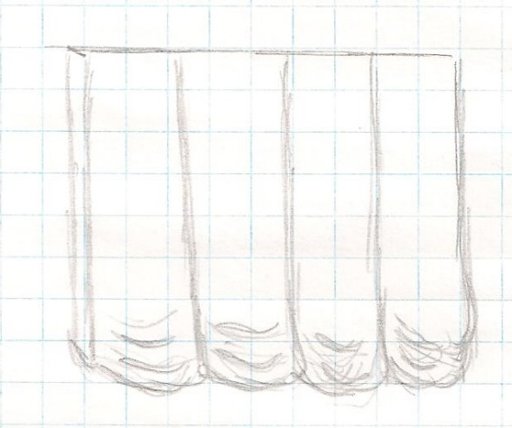

Check out this website to show Balloon shades and variations on them.

<https://www.pinterest.com/explore/balloon-curtains/>

**Calculate:**

* Calculate a Balloon shade outside mount
* Window 60” wide X 48” long with 6” trim added to the window size
* Hang 6” above the top trim on a Velcro board with 3” returns
* 8’ ceiling
* Plain fabric
* Lining and interlining needed?

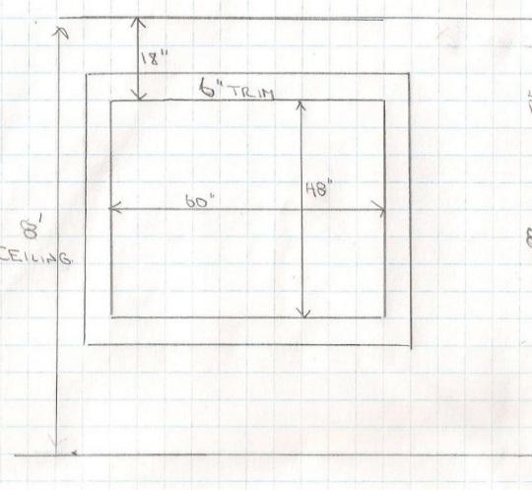

**Answer:**

**Width:**

* Outside mount means that the treatment will extend 2” past the trim
* Window width = 60” window outside mount on a Velcro board
* 3” return +2” past trim + 6” trim + 60” window + 6” trim + 2” past + 3” return=82” + 6” salvage = 88” total
* To make the billowy balloon you need to multiply the width total by 3
* 88 x 3 = 264”
* Do not include salvage in finished width: 88” – 6” salvage = **82” finished width + 3” returns**
* Since fabric is 54” wide, you need to see how many cuts of 54” fabric you need to allow for 264” of width?
* 264” divided by 54 = 4.8 cuts. Round up to the next full cut size = **5 cuts** of 54” fabric to sew together to make the width needed for this treatment.

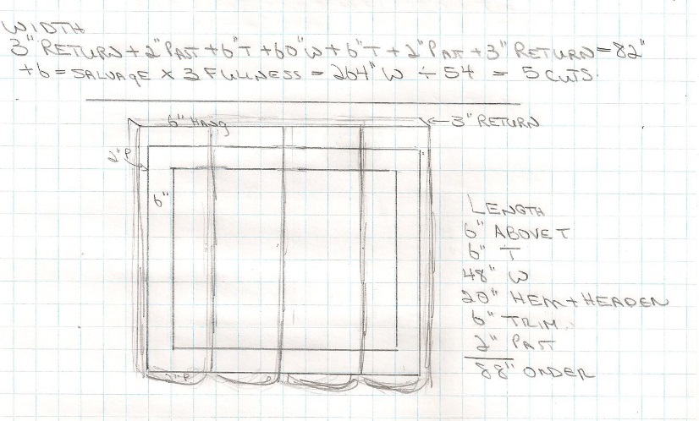

**Length:**

* Since outside mount measure 6” above trim + 6” trim+ length of window 48”+ bottom trim 6” + 2” below trim = **68” finished length.**
* This is not the amount to order.

Balloon shade style needs 20” added length for hem and header and soft bottom

* 68” finished length + 20”= 88” in length to order
* We need 5 cuts of fabric to make this treatment so 88” length X 5 cuts = 440”of fabric to order = divide by 36” = 12.2 yards of fabric. Round up to **12½ to 12¾ yards to order.**
* **Lining**: Same amount of lining and interlining needed to order.
* An interlining is a recommended option to give more body to the folds and give a more custom look to the treatment.



**Layering:**

The nice thing about window treatments is that you can add or take away from them if you want a new look or tire of a treatment you have had for a long time. Layering is the way to do that. If you have a valance, you can always add a blind underneath or if you have a set of drapes with a valance you can remove the valance for a change in the room. I have added the website below to show you many different options to consider.

This website shows some wonderful window treatments using both soft and hard treatments to inspire you!

<http://www.houzz.com/photos/label/lambrequin-window-treatment/p/24>

## Conclusion:

With what you have learned about valances and soft shades you now have a large repertoire of styles to select for window treatments added to what we have covered in previous weeks. There are many books to find with great window ideas. I have collected many over the years that I can also use for inspiration. One that is a must is “The Encyclopedia of Window Fashions” by Charles T. Randall. The newer editions have black and white line drawings that cover all major trends and ideas for every style. It is a great reference that I encourage you to add to your library.

While we cover many styles and kinds of treatments you will not be tested on all of them. You will need to know how to calculate pleated drape/valances, box pleat valances and roman valances/shades for sure.

Instead of practice work this week you have an assignment that is due the last day of this week. Make sure to give yourself enough time to complete it. Refer to the lessons to help you calculate the questions.

********************* End of instructional content *************************

## Evaluation

Fill out the cells on the right in the table below as appropriate. If the evaluation is one of the following, copy and paste the appropriate table(s) after the evaluation table:

* Discussion
* Quiz or test: Insert one table for each question
* Dropbox

|  |  |
| --- | --- |
| **Evaluation** | |
| What type of assessment will be included? | Discussion  Written Assignment  Test or Quiz  Individual Project  Group Project  Other. Describe: Click here to enter text. |
| When is the assessment due? | Due the last day of **this w**eek at 11:55pm |
| How long is the assessment? | 4 window treatments for valances or soft shades. One window per page to be placed in the drop box for week 8. |
| What is the weighted value of the assessment? | Value 10% |
| List the course learning outcomes for this assessment (number and text). This information must match the Evaluation Matrix. | **CLO04:** Outline current fabric trends including pattern, texture and styles as well as uses and benefits of linings to create quality window treatments for various uses.  **CLO05**: Calculate both hard and soft treatments to custom order from a manufacturer or seamstress based on appropriate measurements to complete window treatment order for a client. |
| How does the assessment connect with the lesson or the overall goals of the course? | This assignment gives the student practice to calculate and plan valances and shades that they will also apply in the mid-term, exam and final project for this course. |
| Instructions | Use this area to explain:   * what the assignment is * important criteria   **Assignment #3**  **Shade and valance calculations**  Use one page of graph paper for each window  Draw the window as your working copy in ½” scale  Calculate the following explaining in detail how you came to each amount step by step.  All trim is 3” wide around the window measurements given below.  Label each page by the question #.  **Post all pages into a word document and place in the drop box by the end of week 8.**  1. Calculate the fabric, interlining and lining required for a flat roman shade. It is an inside mount on a window that is 48” wide and 60” long. Plain fabric hung on a Velcro board  2. Calculate the fabric required for an outside mount mock roman valance that has 3 folds. The treatment is hung 6” above the trim and covers the top of the window glass by 4”. The treatment goes past the window trim by 4” on each side and has 4” returns. The window is 70” wide by 70” long.  3. Calculate the fabric, interlining and lining required for a flat roller shade, outside mount hung 4” above the upper trim and covering 2” below the bottom trim when closed. It is hung 2” past the sides of the trim width. The fabric has a 20” pattern repeat. The window glass is 75” wide and 72” long.  4. Calculate the fabric interlining and lining required for a box pleat valance, outside mount that is past the trim by 8” in each side with 4” returns. There are 4 full pleats across the window and ½ pleats at the corners. There is a 16” pattern repeat. The valance is hung at the ceiling height on a ceiling is 10” above the window trim and the valance covers 4” of the window glass. The window is 72” wide and 65” long. |
| Rubric or Marking Scheme | Use this area to explain how the assignment will be assessed or indicate the file name for the rubric.  Click here to enter text.   |  |  |  |  |  |  | | --- | --- | --- | --- | --- | --- | | **Rubrics:** |  |  |  |  |  | | **#3 Assignment** | **Distinguished** | **Good** | **Acceptable** | **Developing** | **Needs work** | | **Working copy drawing (accuracy, ½” scale, dimensions showing, outline of treatment, rod)** | Displays an excellent understanding of the scale, dimensions, measurements and rod/Velcro board height and length | Displays a solid understanding of the scale, dimensions, measurements and rod/Velcro height and length | Some understanding of the scale, dimensions, measurements and rod/Velcro board height and length | Displays limited understanding of the scale dimensions, measurements and rod/Velcro board height and length | Displays little understanding of the scale dimensions, measurements and rod/Velcro board height and length | |  | 5 points | 4 – 7.75 points | 3 - 3.75 points | 2 – 2.75 points | 0 – 1.75 points | | **Critical Thinking and accuracy of calculations** | Clear evidence of critical thinking. Assignment is characterized by clarity of calculations showing correct finished length, order/purchase yardage, rod length and where necessary the pattern repeat, pleat style, railroading, proper lining and or interlining required. | Evidence of critical thinking. Assignment is characterized by clarity of calculations showing correct finished length, order/purchase yardage, rod length and where necessary the pattern repeat, pleat style, railroading, proper lining and or interlining required. | Some evidence of critical thinking. Argument is sometimes clear but lacking some clarity of calculations showing with one error in any of the finished length, order/purchase yardage, rod length and where necessary the pattern repeat, pleat style, railroading, proper lining and or interlining required. | Beginnings of critical thinking; however, assignment tends to not explain meanings of calculations with 2 or more errors in any of the finished length, order/purchase yardage, rod length and where necessary the pattern repeat, pleat style, railroading, proper lining and or interlining required. | Critical thinking not evident. Incorrect calculations and multiple errors in any of the finished length, order/purchase yardage, rod length and where necessary the pattern repeat, pleat style, railroading, proper lining and or interlining required. | |  | 5 points | 4 – 4.75 points | 3- 3.75 points | 2 – 2.75 points | 0 - 1.75 points | | **Communicates clearly** | Assignment is clear and easy to read with no spelling or grammar error | Assignment is clear with some spelling or grammatical errors | Assignment requires concentration to read owing to spelling or grammatical errors | Assignment is difficult to read owing to organization, spelling and or grammatical errors | Assignment is very difficult to read owing to errors in organization, spelling and or grammar | |  | 5 points | 4 – 4.75 points | 3 - 3.75 points | 2 – 2.75 points | 0 – 1.75 points | | **Overall Score** | Distinguished  20 points | Good  16 or more points | Acceptable  12 or more points | Developing  8 or more points | Needs work  O or more points | |